Intermolecular Forces

Intermolecular Forces
Intermolecular forces are generally much weaker than covalent bonds
- Only 16 kJ/mol of energy is required to overcome the intermolecular attraction between HCl molecules in the liquid state (i.e. the energy required to vaporize the sample)
- However, 431 kJ/mol of energy is required to break the covalent bond between the H and Cl atoms in the HCl molecule
Thus, when a molecular substance changes states the atoms within the molecule are unchanged
The temperature at which a liquid boils reflects the kinetic energy needed to overcome the attractive intermolecular forces (likewise, the temperature at which a solid melts).
Thus, the strength of the intermolecular forces determines the physical properties of the substance
Attractive forces between neutral molecules
- London dispersion forces
- Dipole-dipole forces
- Hydrogen bonding forces
Typically, dipole-dipole and dispersion forces are grouped together and termed van der Waals forces (sometimes the hydrogen bonding forces are also included with this group)
Attractive forces between neutral and charged (ionic) molecules
- ion-dipole forces
Note that all of these forces will be electrostatic in nature

London Dispersion Forces
Nonpolar molecules would not seem to have any basis for attractive interactions.
- However, gases of nonpolar molecules can be liquefied indicating that if the kinetic energy is reduced, some type of attractive force can predominate.
- Fritz London (1930) suggested that the motion of electrons within an atom or non-polar molecule can result in a transient dipole moment
A Model To Explain London Dispersion Forces:
Helium atoms (2 electrons)
- Consider the particle nature of electrons
- The average distribution of electrons around each nucleus is spherically symmetrical
- The atoms are non-polar and posses no dipole moment
- The distribution of electrons around an individual atom, at a given instant in time, may not be perfectly symmetrical
  - Both electrons may be on one side of the nucleus
  - The atom would have an apparent dipole moment at that instant in time (i.e. a transient dipole)
  - A close neighboring atom would be influenced by this apparent dipole - the electrons of the neighboring atom would move away from the negative region of the dipole
Due to electron repulsion, a temporary dipole on one atom can induce a similar dipole on a neighboring atom
- This will cause the neighboring atoms to be attracted to one another
- This is called the London dispersion force (or just dispersion force)
- It is significant only when the atoms are close together
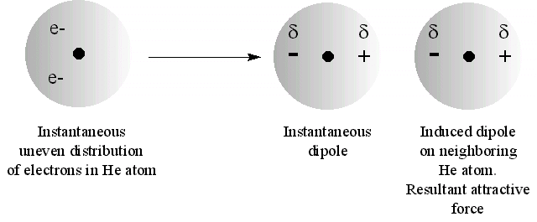

The ease with which an external electric field can induce a dipole (alter the electron distribution) with a molecule is referred to as the "polarizability" of that molecule
- The greater the polarizability of a molecule the easier it is to induce a momentary dipole and the stronger the dispersion forces
- Larger molecules tend to have greater polarizability
  - Their electrons are further away from the nucleus (any asymmetric distribution produces a larger dipole due to larger charge separation)
  - The number of electrons is greater (higher probability of asymmetric distribution)
thus, dispersion forces tend to increase with increasing molecular mass
- Dispersion forces are also present between polar/non-polar and polar/polar molecules (i.e. between all molecules)

Dipole-Dipole Forces
A dipole-dipole force exists between neutral polar molecules
- Polar molecules attract one another when the partial positive charge on one molecule is near the partial negative charge on the other molecule
- The polar molecules must be in close proximity for the dipole-dipole forces to be significant
- Dipole-dipole forces are characteristically weaker than ion-dipole forces
- Dipole-dipole forces increase with an increase in the polarity of the molecule
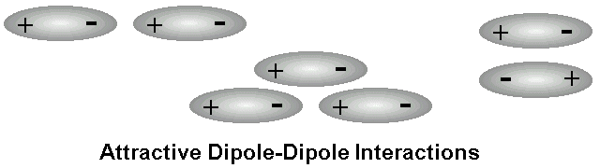

Boiling points increase for polar molecules of similar mass, but increasing dipole:
Substance | Molecular Mass (amu) | Dipole moment, u (D) | Boiling Point (°K)
Propane | 44 | 0.1 | 231
Dimethyl ether | 46 | 1.3 | 248
Methyl chloride | 50 | 2.0 | 249
Acetaldehyde | 44 | 2.7 | 294
Acetonitrile | 41 | 3.9 | 355

Hydrogen Bonding
A hydrogen atom in a polar bond (e.g. H-F, H-O or H-N) can experience an attractive force with a neighboring electronegative molecule or ion which has an unshared pair of electrons (usually an F, O or N atom on another molecule)
Hydrogen bonds are considered to be dipole-dipole type interactions
- A bond between hydrogen and an electronegative atom such as F, O or N is quite polar:
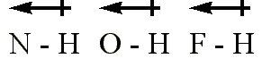

- The hydrogen atom has no inner core of electrons, so the side of the atom facing away from the bond represents a virtually naked nucleus
- This positive charge is attracted to the negative charge of an electronegative atom in a nearby molecule
- Because the hydrogen atom in a polar bond is electron-deficient on one side (i.e. the side opposite from the covalent polar bond) this side of the hydrogen atom can get quite close to a neighboring electronegative atom (with a partial negative charge) and interact strongly with it (remember, the closer it can get, the stronger the electrostatic attraction)
  - Hydrogen bonds vary from about 4 kJ/mol to 25 kJ/mol (so they are still weaker than typical covalent bonds.
  - But they are stronger than dipole-dipole and or dispersion forces.
  - They are very important in the organization of biological molecules, especially in influencing the structure of proteins
Water is unusual in its ability to form an extensive hydrogen bonding network
- As a liquid the kinetic energy of the molecules prevents an extensive ordered network of hydrogen bonds
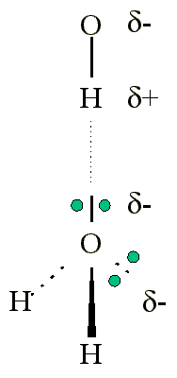
- When cooled to a solid the water molecules organize into an arrangement which maximizes the attractive interactions of the hydrogen bonds
  - This arrangement of molecules has greater volume (is less dense) than liquid water, thus water expands when frozen
  - The arrangement has a hexagonal geometry (involving six molecules in a ring structure) which is the structural basis of the six-sidedness seen in snow flakes
  - Each water molecule can participate in four hydrogen bonds
    - One with each non-bonding pair of electrons
    - One with each H atom
Ion-dipole
- Involves an interaction between a charged ion and a polar molecule (i.e. a molecule with a dipole)
- Cations are attracted to the negative end of a dipole
- Anions are attracted to the positive end of a dipole
- The magnitude of the interaction energy depends upon the charge of the ion (Q), the dipole moment of the molecule (u) and the distance (d) from the center of the ion to the midpoint of the dipole
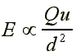
- Ion-dipole forces are important in solutions of ionic substances in polar solvents (e.g. a salt in aqueous solvent)

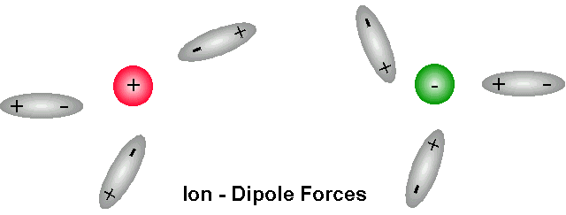

Ion-ion

1996 Michael Blaber

