From PurpleMath.com
- Solve x + 6 = –3
I want to get the x by itself; that is, I want to get "x" on one side of the "equals" sign, and some number on the other side. Since I want just x on the one side, this means that I don't like the "plus six" that's currently on the same side as the x. Since the 6 is added to the x, I need to subtract to get rid of it. That is, I will need to subtract a 6 from the x in order to "undo" having added a 6 to it.
This brings up the most important consideration with equations: No matter what kind of equation you're dealing with -- linear or otherwise -- whatever you do to the one side, you must do the exact same thing to the other side! Equations are like toddlers in this respect: You have to be totally, totally fair!
Whatever you do to an equation,
do the S A M E thing
to B O T H sides of that equation!
Probably the best way to keep track of this subtraction of 6 from both sides is to format your work this way:
$--6$
-6 -6
x = -9
What you see here is that I've subtracted 6 from both sides, drawn an "equals" bar underneath both sides, and added down: x plus nothing is x, 6 minus 6 is zero, and –3 plus –6 is –9. The solution is the last line of my work: x = –9.
The same "undo" procedure works for subtraction:
- Solve x – 3 = –5
Since I want to get x by itself, I don't want the "–3" that's with the variable. The opposite of subtraction is addition, so I'll undo the –3 by adding 3 to both sides, and then adding down:
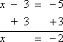
Then the solution is x = –2.

$Type equation here.$Solving Multi-Step Linear Equations (page 3 of 4)
Sections: One-step equations, Multi-step equations, "No solution" and "all x" equations

Most linear equations require more than one step for their solution. For instance:
- Solve 7x + 2 = –54
I need to undo the "times seven" and the "plus two". There is no rule about which "undo" I should do first. However, if I first divide through by 7, I'm going to have fractions. Personally, I prefer to avoid fractions if possible, so I almost always do any plus / minus before any times / divide:
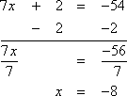
Then the solution is x = –8.
Formatting your homework and showing your work in the manner I have done above is, in my experience, fairly universally acceptable. However (warning!), it is also a good idea to clearly rewrite your final answer at the end of each exercise, as shown (in purple) above. Don't expect your grader to take the time to dig through your work and try to figure out what you probably meant your answer to be. Format your work so as to make your meaning clear!
- Solve –5x – 7 = 108
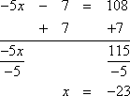
Then the solution is x = –23.
- Solve 3x – 9 = 33 Copyright © Elizabeth Stapel 2002-2011 All Rights Reserved
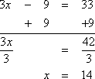
Then the solution is x = 14.

- Solve 5x + 7x = 72
First, I need to combine like terms on the left; then I can solve:
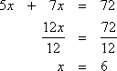
Then the solution is x = 6.
- Solve 4x – 6 = 6x
I need to move all the x's over to one side or the other. To avoid negative coefficients on my variables, I usually move the smaller x; in this case, I'll subtract the 4x over to the other side:
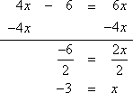
Then the solution is x = –3.
In the above exercise, note that it is perfectly okay to have the "x=" be on the right. The variable is not "required" to be on the left; we're just used to seeing it there. It's alright if your solution works out with the variable on the right. However (warning!), I have heard of some instructors who insist that the variable be placed on the left-hand side in the final answer. (No, I'm not making that up.) If you have any doubts about your instructor's formatting preferences, ask now.
- Solve 8x – 1 = 23 – 4x
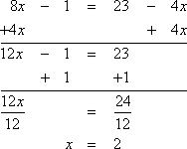
Then the solution is x = 2.

- Solve 5 + 4x – 7 = 4x – 2 – x
Before I can solve, I need to combine like terms:
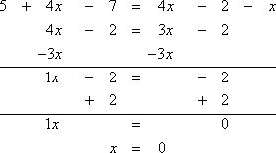
Then the solution is x = 0.
It is perfectly fine for x to have a value of zero. Zero is a valid solution. Do not say that this equation has "no solution"; it does indeed have a solution, that solution being x = 0.
- Solve 0.2x + 0.9 = 0.3 – 0.1x
This equation solves just like all the other linear equations. It just looks worse because of the decimals. But that's easy to fix: however many decimal places I have, I can multiply by "1" followed by that number of zeroes. In this case, I'll multiply through by 10:
10(0.2x) + 10(0.9) = 0(0.3) – 10(0.1x)
2x + 9 = 3 – 1x
Then I solve as usual:
2x + 1x + 9 – 9 = 3 – 9 – 1x + 1x
3x = –6
x = –2
If one of the decimals had had two decimal places, then I'd have multiplied through by 100; for three, I'd have multiplied through by 1000
- Solve 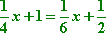
To simplify my computations for equations with fractions, I can first multiply through by the common denominator. For this equation, the common denominator is 12:
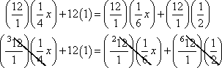
3x + 12 = 2x + 6
3x – 2x + 12 – 12 = 2x – 2x + 6 – 12
x = –6

